SHRU SPECIFIC RECOVERY IMPLEMEMTATION STRATEGY
  - DRAFT

Comments Requested On:
- The SHRU and basin/watershed descriptions of habitats and important features
- The SHRU goals and objectives

Overview:
The purpose of the SHRU strategy is to provide a narrative of the habitat features and locations within each SHRU that support the best opportunities for Atlantic salmon recovery. The strategy identifies opportunities within each SHRU based on the quantity and quality of habitats and the magnitude of existing threats within particular areas.
The SHRU work plans identify SHRU level threats and specific activities that, upon their completion, would address threats that currently constrain the survival and recovery of Atlantic salmon within each SHRU. The work plans also identify opportunistic activities within each SHRU that, if not acted upon in the immediate future, may not be available to act upon at a later time. The site specific threats and recovery activities largely represent specific threats and activities that will be worked on, given availability of resources, over the next five years. The work plans are not intended to be comprehensive work plans of all the Activities that can be done to recover salmon. The work plans are intended to be dynamic. The history of the salmon program has demonstrated that the activities we do change as a function of new and emerging science, changes in species abundance and distribution, and changes in available resources. Therefore, as new strategies emerge from ongoing science, and as new projects and opportunities are identified, the work plans should be updated to accommodate those changes.

SHRU RECOVERY STRATEGIES

Penobscot SHRU Strategy:

Summary
In the Penobscot SHRU, there are approximately 323,700 units of habitat features that could support Atlantic salmon spawning and juvenile rearing. Of this, approximately 211,000 units of habitat are in areas designated as Critical Habitat with an estimated equivalent productive capacity of 66,000 units based on the apparent suitability of habitats and the threats that affect their value for spawning and rearing. Because of dams, all but approximately 8,000 units of this habitat are above dams with fish passage operations that have not yet demonstrated to be sufficient to allow for both survival and recovery. For many of the hydro dams in the areas with designated critical habitat in the Penobscot SHRU, project modifications and studies are underway to help assure that these dams and their operations allow for survival and recovery.

Strategy Objectives
- Increase abundance, diversity and resilience by providing access to areas that support the highest quantities and most suitable habitats
- Increase diversity and resilience by ensuring that salmon have access to diverse and rare habitats
- Increase diversity and resilience by ensuring that salmon are geographically widespread
- Prevent extinction and increase survival by the removal or abatement of threats to salmon and their habitats
- Restoration of the co-evolve suite of diadromous fish that are part of the ecosystem that Atlantic salmon depend upon

Reasons Why the Penobscot SHRU is Important to Salmon Recovery:
- The Penobscot stock within the Penobscot River is the largest and most genetically diverse in the Gulf of Maine DPS
- The Penobscot SHRU contains the largest abundance of freshwater spawning and nursery habitats that are currently accessible to Atlantic salmon.
- The historical record (C. Atkins 1868) suggests that the Penobscot has the potential to produce upwards of 100,000 returning adult Atlantic salmon when freshwater and marine conditions are favorable. Rivers with abundant, highly suitable habitats that can support large populations are more resilient to anthropogenic and environmental stressors then smaller rivers with less habitat.
- The Penobscot SHRU contains a wide range of diverse habitats that is necessary for supporting an abundant, diverse and resilient population of Atlantic salmon.

Areas that provide the best opportunities for achieving the strategy objectives:
- The upper Piscatiquis watershed including the Piscatiquis River and its tributaries above Guilford, and the East, West and Middle Branches of the Pleasant River and their tributaries because of their abundant, high quality habitats
- The upper Mattawamkeag Watershed including the East Branch Mattawamkeag River because of its abundant, highly suitable habitats
- The East Branch Penobscot River and its Tributaries because of its abundant highly suitable habitats
- The lower Penobscot Tributaries that are not obstructed by dams, including Kenduskeag Stream and the Souadabscook River.
- The Orland River because of its considerable opportunities for river herring.
- Phase 1 lakes and ponds identified in Maine DMR’s Penobscot Operational Plan because they provide considerable opportunities for river herring.
- All other areas designated as Critical Habitat

Important Features by Watershed

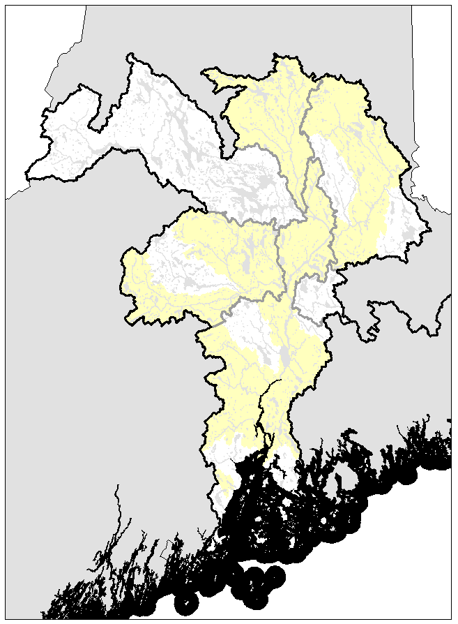
Critical Habitat
West Branch Penobscot
Penobscot River below the former Veazie dam and its tributaries
Piscatiquis
Mattawamkeag
East Branch Penobscot
Penobscot River above the former Veazie dam and its tributaries
Passadumkeag

Penobscot Estuary, Bay and Northeast Shelf
Important Features:
- All Penobscot SHRU rivers enter Penobscot Bay, the second largest embayment on the US East Coast. The Penobscot River empties into the Penobscot Estuary, a system approximately 50 km long from head-of-tide near Eddington to Fort Point. The geography of this embayment is important because threats within the estuary and bay could impact salmon migrating through this area during their transition between marine and freshwater habitats where both new predators and prey items are encountered.

- Three large islands split the Bay in half providing eastern and western corridors throughout much of its length. This complex structure results in different freshwater influences, tidal currents, and circulation patterns moving seaward into the Gulf of Maine. The outer western corridor is the preferred entry point to the Gulf of Maine for emigrating smolts.

- Offshore from the mouth of Penobscot Bay, the Gulf of Maine Coastal Current (GMCC), splits into two branches just downstream of Isle au Haut. The Eastern Maine Coastal Current (EMCC) extends along the coast of Maine to Penobscot Bay then turns offshore and the Western Maine Coastal Current (WMCC) extends westward from Penobscot Bay to Massachusetts Bay. Depending on travel routes, post-smolts may be challenged or assisted by these currents.

- The upper watershed, estuary, and bay are among the most industrialized waterways in Maine. Point sources influencing the estuary/bay include paper mills, chemical plants, wastewater treatment, oil tank farms, and commercial ports. Nonpoint sources include agricultural, suburban, and urban landscapes. Point source and non-point sources of pollution may be harmful to Atlantic salmon, particularly smolts that are sensitive to pollutants while in transition between the freshwater and marine environment.

- Important fishery for the State of Maine – approximately 50% of Maine’s lobster is caught in Penobscot Bay. Extensive tourism and recreational boating as well as moderate commercial vessel traffic including routine ferry operations are prominent. All these activities could influence the ecological interactions between species in this ecosystem.

- There are ATS aquaculture net pens located near Harbor Island and Toothacker Bay that are presently unoccupied but are slated to be stocked in the near future. These aquaculture sites reside on the border between the PN and DE SHRUs. There are also oyster test net pens located in the Bagaduce. Aquaculture escapes are a threat to ATS populations through disease, outbreeding, and competition.

- In the past, Dice Head off Castine has served as a test site for wind power. Presently there are no wind or turbine power test projects occurring within Penobscot Bay but areas have been identified as potential sites. These activities could directly or indirectly harm migrating ATS.
- In addition to Atlantic salmon, the Penobscot Estuary and Bay are home to several diadromous species including alewife, blueback herring, American shad, rainbow smelt, Atlantic sturgeon, shortnose sturgeon and striped bass. Restoration of all components of this diadromous suite is an objective of salmon recovery and monitoring of interactions between species in this habitat is important to understand recovery progress.

Lower Penobscot SHRU below the site of the old Veazie Dam and its Tributaries

Important Features
- The habitat in the lower mainstem Penobscot River below the site of the old Veazie Dam is largely unsuitable for spawning and juvenile rearing but is an essential migratory corridor for Atlantic salmon connecting freshwater nursery habitats to the marine environment.
- The tributaries, including the Kenduskeag, Souadabscook, Ducktrap and Marsh Stream have approximately 19,000 units of habitat with an estimated equivalent production capacity of 10,000 units of habitat (estimated as a function of habitat quality and the threats that impair the value of that habitat). One hydro dam and several non-hydro dams impair access and survival to these habitats.
- The tributaries of the lower Penobscot are unique to the Penobscot because, other than Marsh Stream, they are not impacted by hydro development. Subsequently, the survival of emigrating smolts is not compromised by turbine entrainment and de-scaling issues associated with hydro-dams; a factor that can significantly affect the overall survival and sustainability of populations above hydro-projects if reasonable management measures are not implemented.
- The lower mainstem Penobscot supports spawning and nursery habitats for American shad and blueback herring, and nursery habitats for alewives that may serve as a predator buffer to both emigrating Atlantic salmon smolts and immigrating adults.
- The low gradient habitats of the lower Penobscot tributaries result in higher water temperatures and higher substrate embeddedness which likely limits the overall productive capacity of these tributaries.
- The most abundant Atlantic salmon habitats in the lower Penobscot are in Marsh Stream and Kenduskeag Stream.
- The most suitable habitats for spawning and juvenile rearing in the lower Penobscot are in the upper Kenduskeag and its tributaries, the Ducktrap River, and Cove Brook.
- The most abundant river herring habitats are in the Souadabscook and Orland River watersheds.
- The most unique habitats may be found in Cove Brook in the lower Penobscot. Cove Brook has very little spawning and nursery habitats for salmon, though extremely high alkalinity and cold water makes the habitats highly productive.
- Kenduskeag Stream has high alkalinity waters that could generate higher productivity.
- Sedgeunkedunk Stream provides a unique learning opportunity on diadromous fish recolonization following the removal of two dams that had prevented access to the watershed for more than a century.

Penobscot River above Veazie and its tributaries

Important Features
- The mainstem Penobscot River above the former Veazie Dam and its small tributaries have approximately 33,000 units of spawning and nursery habitat with an estimated equivalent production capacity of approximately 8,000 units of habitat as a function of habitat quality and the threats that impair the value of that habitat. Three hydro dams within this reach impair access and survival of salmon within these habitats.
- The mainstem Penobscot is essential to Atlantic salmon because it’s an essential migratory corridor connecting freshwater nursery habitats to the marine environment.
- The most abundant salmon habitats are within the mainstem Penobscot although hydro dams, high summer temperatures and high densities of smallmouth bass significantly decrease its value for Atlantic salmon.
- The mainstem Penobscot above the former Veazie Dam has abundant spawning and nursery habitats for blueback herring and American shad.
- Blackman Stream and its associated lakes and ponds, Pushaw Lake, and Mattimiscontis Stream and its lakes and ponds have abundant spawning and nursery habitats for alewives.

Passadumkeag River and its tributaries

Important Features
- The Passadumkeag River and its tributaries have approximately 8,000 units of habitat with an estimated equivalent production capacity of 1,500 units of habitat (estimated as a function of habitat quality and the threats that impair the value of that habitat). One hydro dam in the Passadumkeag, one in the mainstem Penobscot, and several non-hydro dams in the Passadumkeag impair access and survival to these habitats.
- In general, the Passadumkeag has relatively low quantity and quality salmon habitat, although some of its tributaries do have very good spawning and nursery habitats.
- Cold Stream Pond and Saponac Pond have the greatest potential for alewife production in the Passadumkeag. Cold Stream Pond is currently inaccessible because of dams.
- The mainstem Passadumkeag may provide opportunities for blueback herring and American shad spawning.
- Grand Falls is likely a barrier to river herring and was believed to be a barrier to Atlantic salmon. In recent years though, one Atlantic salmon has been documented above Grand Falls.

Mattawamkeag River and its tributaries

Important Features
- The Mattawamkeag River and its tributaries have approximately 33,000 units of habitat with an estimated equivalent production capacity of 7,713 units of habitat (estimated as a function of habitat quality and the threats that impair the value of that habitat). Two hydro dams in the mainstem Penobscot impair access and survival to these habitats.

- The Mattawamkeag is very important to Atlantic salmon because of the presence of high quality and quantity of nursery habitat for Atlantic salmon, particularly in the East Branch Mattawamkeag River.
- Tributaries of the lower Mattawamkeag, particularly Mollunkus Stream may contain suitable, abundant habitats, but they have not been recently surveyed or assessed.
- The lower mainstem Mattawamkeag may provide ample nursery habitats for blueback herring.
- The Mattawamkeag River does not have any mainstem dams that would affect survival and migration. However, there are two mainstem dams on the Penobscot River below the confluence with the Mattawamkeag.
- The Lower Mattawamkeag has abundant smallmouth bass populations that could prey heavily on emigrating smolts.

Piscataquis River and its Tributaries

Important Features
- The Piscataquis River and its tributaries have approximately 64,500 units of habitat with an estimated equivalent production capacity of 20,500 units of habitat (estimated as a function of habitat quality and the threats that impair the value of that habitat). One hydro dam on the mainstem Penobscot and four mainstem dams with intermittent hydro operations on the Piscataquis impair access and survival to these habitats.
- The Piscataquis River and its tributaries are very important to Atlantic salmon because of the presence of high quality and quantity of nursery habitat for Atlantic salmon, particularly in Kingsbury Stream, the Piscataquis above the town of Guilford, the East, West and Middle branches of the Pleasant River and their tributaries.
- The Lower Piscataquis River has spawning and nursery habitats that could support abundant populations of blueback herring and American shad.
- The Milford Dam in the mainstem Penobscot, and the Howland Dam on the Piscataquis near its confluence with the Penobscot, may impair passage and survival of Atlantic salmon that use the Piscataquis for spawning and rearing. A fish bypass was recently constructed around Howland Dam and effectiveness testing to determine the success of diadromous fish passage through the bypass will occur in the spring of 2016.
- The Browns Mills, Moosehead and Guilford Dams in the Piscataquis may also impair passage and survival of Atlantic salmon that use the Piscataquis for spawning and rearing.
- Large sections of the Piscataquis River and its tributaries have very abundant, but low quality habitats because of dams, high water temperatures and an abundance of smallmouth bass. This includes the mainstem Piscataquis below Guilford, the Pleasant River from Brownville to its confluence, and the East Branch Pleasant River from Silver Lake down to Brownville.
- Road crossings and land use practices impair/prevent access and degrade water quality of cool water tributaries throughout the Piscataquis.

East Branch Penobscot River

Important Features:
- The East Branch Penobscot River and its tributaries have approximately 22,000 units of habitat with an estimated equivalent production capacity of 9,000 units of habitat (estimated as a function of habitat quality and the threats that impair the value of that habitat). Three hydro dams on the mainstem Penobscot impair access and survival in these habitats.
- The East Branch Penobscot and its tributaries are very important to Atlantic salmon because of the presence of high quality and quantity of nursery habitat for Atlantic salmon, particularly in the East Branch above Wassataquoik Stream and its tributaries, and Wassataquoik Stream.
- Little and Big Spring Brooks and Lunksoos Stream are important cold water habitats often utilized as nursery habitats by juvenile Atlantic salmon.
- The Mattaseunk Dam, West Enfield Dam and Milford Dam in the mainstem Penobscot, may impair passage and survival of Atlantic salmon that use the East Branch for spawning and rearing.
- The Seboeis River, tributary to the East Branch, has very abundant, but low quality habitats because of high water temperatures and an abundant smallmouth bass population.

West Branch Penobscot River

Important Features:
- The West Branch Penobscot River and its tributaries have approximately 80,000 units of habitat. Currently, the West Branch is inaccessible due to dams without fish passage within the mainstem of the West Branch.
- The West Branch Penobscot and its tributaries have very high quality and quantity of nursery habitat that could provide considerable opportunities for Atlantic salmon spawning and rearing if they were accessible.
- The Mattaseunk Dam, West Enfield Dam and Milford Dam in the mainstem Penobscot, may impair passage and survival of Atlantic salmon up to the West Branch Penobscot River.
- The Medway Dam, Penobscot Mills Project Dams (Stone Dam, East Millinocket and Dolby Dam), North Twin Dam, Ripogenus Dam, Seboomook Dam, Canada Falls Dam as well as many other small dams obstruct passage of all diadromous fish in the West Branch including Atlantic salmon.

Downeast Coastal SHRU Strategy

Summary
In the Downeast SHRU, there are approximately 61,300 units of habitat features that could support Atlantic salmon spawning and juvenile rearing. Of this, approximately 53,400 units of habitat are in areas designated as Critical Habitat with an estimated equivalent productive capacity of 29,000 units based on the quality of the habitats and the threats that affect their value for spawning and rearing. Approximately 4,200 units of this habitat are above hydro dams with fish passage operations that have not yet demonstrated to be sufficient to allow for both survival and recovery. For the two hydro dams on the Union River in the Downeast SHRU (e.g., Ellsworth and Graham Station Dams), preliminary discussions are underway to identify ways of assuring that these dams and their operations allow for survival and recovery of Atlantic salmon.

Strategy Objectives
- Increase abundance, diversity and resilience by providing access to areas that support the highest quantities and highest quality habitats
- Increase diversity and resilience by ensuring that salmon have access to diverse and rare habitats
- Increase diversity and resilience by ensuring that salmon are geographically widespread
- Prevent extinction and increase survival by the removal or abatement of threats to salmon and their habitats
- Restoration of the co-evolve suite of diadromous fish that are part of the ecosystem that Atlantic salmon depend upon

Reasons Why the Downeast SHRU is Important to Salmon Recovery:
- The Downeast SHRU contains five of the seven remaining locally adapted genetic stocks in the GOM DPS, accounting for a significant component of the GOM DPS’s genetic diversity.
- Of the five rivers in the Downeast SHRU that contain locally adapted stocks, there are no hydro projects and only one mainstem dam, which may partially account for why the stocks in these rivers have managed to persist albeit at very low numbers.
- The Downeast SHRU represents an important link between two large river basins that once supported very large populations of Atlantic salmon – the Penobscot and the St. John. This is important to assure that the GOM DPS does not become too distant and isolated from other Atlantic salmon populations.
- The combination of granite bedrock, glacial eskers and moraines, vast peat bogs and relatively flat topography makes the hydrology and water chemistry of the Downeast SHRU unique to the GOM DPS. These unique features would suggest that Atlantic salmon in these rivers may contain unique genes well adapted for this area and therefore should warrant their preservation.

Areas that provide the best opportunities for achieving the strategy objectives:
- The entire Dennys, East Machias, Machias, Pleasant, and Narraguagus Rivers have abundant suitable habitats with locally adapted populations of Atlantic salmon.
- The West Branch Union River has abundant, suitable spawning and nursery habitats for Atlantic salmon and the lakes and ponds in the Union River drainage provide considerable spawning and nursery habitats for river herring and historically, American shad.

Important Features by Watershed

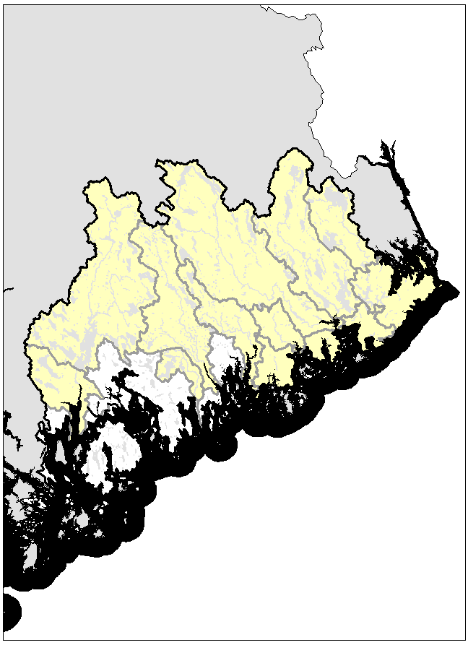
MDI
Lamoine Coastal
Tunk Stream
Roque Bluff
Chandlerr
Boise Bubert
Grand Manan ChannBubert
Union
Dennys
Pleasant
Machias

East Machias

Narraguagus

Critical Habitat

Dennys River

Important Features
- The Dennys River and its tributaries have approximately 1,700 units of habitat with an estimated equivalent production capacity of 1,100 units of habitat (estimated as a function of habitat quality and the threats that impair the value of that habitat).
- The Dennys River drains into Cobscook Bay which is geographically and hydrologically complex. Cobscook Bay has a very narrow opening, a rugged coastline, has numerous islands, and has some of the highest tides and strongest currents in the continental U.S. because of its shape and location. This Bay likely imposes strong selection pressures on Atlantic salmon. As such, salmon that are successful in the Dennys should be conserved as these fish may be uniquely adapted to cope with these challenges.

- The mainstem Dennys River has no dams up to Meddybemps Lake.

- Cathance Stream is the Dennys only major tributary. Greatworks Dam and its headpond serve as wildlife habitat, but the dam is a partial barrier to Atlantic salmon migration.

- Meddybemps and Cathance Lakes provide ample spawning and nursery habitats for river herring.

- As noted previously, the Dennys has one of seven remaining locally adapted stocks in the GOM DPS.

East Machias River

Important Features
- The East Machias River and its tributaries have approximately 6,100 units of habitat with an estimated equivalent production capacity of 4,000 units of habitat.
- The East Machias River contains numerous lakes and ponds that provide considerable opportunities for alewife and blueback herring spawning and rearing.

- The East Machias contains one of seven remaining locally adapted stocks within the GOM DPS.

- The East Machias has no mainstem dams, except for Pokey Dam that is at the outlet of Crawford Lake; a headwater lake to the East Machias.

- The numerous lakes and ponds throughout the East Machias watershed from its headwaters to the estuary are a relatively unique feature among salmon rivers in Maine. Atlantic salmon populations that occupy areas containing unique features and habitats should be preserved.

Machias River

Important Features
- The Machias River and its tributaries have approximately 15,000 units of habitat with an estimated equivalent production capacity of 10,000 units of habitat (estimated as a function of habitat quality and the threats that impair the value of that habitat).
- The Machias contains one of seven remaining locally adapted stocks within the GOM DPS.

- The Machias has no mainstem dams that would block or impede access of Atlantic salmon.

- More than 60,000 acres of the Machias River riparian corridor, spanning 252 miles of the Machias River and its tributaries, are protected by the state of Maine and land trusts either through direct ownership or conservation easements. The corridor protections restrict timber cutting for a 1,000 feet on both sides of the mainstem and its major tributaries.

- Bad Little Falls in Machias is a substantial set of ledge falls that has likely imposed selection pressures on the diadromous fish that use the Machias. Any diadromous fish would have to be well suited to traverse these falls. Consequently, Atlantic salmon in the Machias may possess unique adaptations to successfully navigate these falls that should be preserved.

- Old Stream in the Machias River Basin is the most productive salmon stream in the Downeast SHRU based on fry and parr densities.

Pleasant River

Important Features
- The Pleasant River and its tributaries have approximately 3,000 units of habitat with an estimated equivalent production capacity of 2,000 units of habitat (estimated as a function of habitat quality and the threats that impair the value of that habitat).
- The Pleasant River contains one of seven remaining locally adapted stocks within the GOM DPS.

- The Pleasant has no mainstem dams that would block access of Atlantic salmon, although Saco Falls and the remnants of a dam at Saco Falls may impede salmon under some flow conditions.

- The Pleasant River has very low pH under some flow conditions. Much of the low pH can be attributed to very high levels of dissolved organic matter in the water as a function of the watershed’s landscape features. It is possible that a portion of the low pH is attributed to anthropogenic acidification. Atlantic salmon that are successful in the Pleasant River may be better adapted to cope with lower pH environments and therefore, should be preserved.

Narraguagus River

Important Features
- The Narraguaugus River and its tributaries have approximately 6,500 units of habitat with an estimated equivalent production capacity of 4,100 units of habitat (estimated as a function of habitat quality and the threats that impair the value of that habitat).
- The Narraguagus contains one of seven remaining locally adapted stocks in the GOM DPS.

- The Narraguagus has abundant, high quality habitats that support Atlantic salmon spawning and rearing.

- The Cherryfield Dam in the town of Cherryfield is a partial barrier to Atlantic salmon, river herring and American shad in the lower Narraguagus River and likely results in migration delays that may increase Atlantic salmon’s vulnerability to predation.

- The West Branch of the Narraguagus has similar water chemistry to the Pleasant River and may impose high selection pressures on salmon that live there.

- The Narraguagus has the most comprehensive, long term dataset on Atlantic salmon stock performance in the Gulf of Maine DPS, and as such, serves as a primary indicator of overall Atlantic salmon health and abundance in the GOM DPS.

Union River

Important Features
- The Union River and its tributaries have approximately 12,000 units of habitat with an estimated equivalent production capacity of 4,200 units of habitat (estimated as a function of habitat quality and the threats that impair the value of that habitat), including two mainstem hydro dams.
- The West Branch Union River has abundant, suitable spawning and nursery habitats for Atlantic salmon.
- The lakes and ponds in the Union River drainage provide considerable spawning and nursery habitats for river herring and historically, American shad.
- Two mainstem dams, Graham Station and Ellsworth, impair passage and survival of Atlantic salmon and river herring in the Union River watershed.

Boise Bubert, Chandler River, Grand Manan, Lamoine Coastal, Mt. Desert, Roque Bluff, and Tunk Stream

Important Features
- Boise Bubert, Chandler River, Grand Manan, Lamoine Coastal, Mt. Desert, Roque Bluff, and Tunk Stream and their tributaries have approximately 17,000 units of habitat with an estimated equivalent production capacity of 6,000 units of habitat (estimated as a function of habitat quality and the threats that impair the value of that habitat).

MERRYMEETING BAY Strategy

Summary
In the Merrymeeting Bay SHRU, there are approximately 373,000 units of habitat features that could support salmon spawning and juvenile rearing. Of this, approximately 136,000 units of habitat are in areas designated as Critical Habitat with an estimated equivalent productive capacity of 40,000 units based on the quality of the habitats and the threats that affect their value for spawning and rearing. Approximately 29,000 units of this habitat are above hydro dams with fish passage operations that have not yet demonstrated to be sufficient to allow for both survival and recovery. For many of the hydro dams in the areas with designated critical habitat in the Merrymeeting Bay SHRU, project modifications and studies are underway to help assure that these dams and their operations allow for survival and recovery.

Strategy Objectives
- Increase abundance, diversity and resilience by providing access to areas that support the highest quantities and highest quality habitats
- Increase diversity and resilience by ensure that salmon have access to diverse and rare habitats
- Increase diversity and resilience by ensuring that salmon are geographically widespread
- Prevent extinction and increase survival by the removal or abatement of threats to salmon and their habitats
- Restoration of the co-evolve suite of diadromous fish that are part of the ecosystem that Atlantic salmon depend upon

Reasons Why the Merrymeeting Bay SHRU is Important to Salmon Recovery:
- The Kennebec River in the Merrymeeting Bay SHRU contains the most abundant, most suitable habitats for Atlantic salmon in the GOM DPS.
- The Merrymeeting Bay SHRU contains a wide range of diverse habitats that are necessary for supporting an abundant, diverse and resilient population of Atlantic salmon.
- The historical record (C. Atkins 1868) suggests that the Kennebec River has the potential to produce at least 100,000 returning adult Atlantic salmon when freshwater and marine conditions are favorable. Rivers with abundant, high quality habitats that can support large populations are more resilient to anthropogenic and environmental stressors then smaller rivers.
- The Sheepscot River in the Merrymeeting Bay SHRU contains the southern-most locally adapted stock of Atlantic salmon.
- The Kennebec River in the Merrymeeting Bay SHRU may have greater resilience to climate change because of its high gradient systems and cool water influences.
- The Merrymeeting Bay SHRU has tremendous capacity for river herring production that likely conveys many ecological benefits to Atlantic salmon (see Saunders et al. 2006)

Areas that provide the best opportunities for achieving the strategy objectives:
- The Sandy River in the Kennebec Watershed and its Tributaries provides abundant, high quality habitats.
- The Sheepscot River Watershed provides a locally adapted stock.
- The Little River on the Androscoggin currently provides the best opportunity for Atlantic salmon spawning and rearing in the Androscoggin River given the river’s current configuration of dams.
- The Sabbatus River provides considerable opportunities for river herring spawning and rearing.
- The St. George River provides considerable opportunities for river herring and has some good habitat for Atlantic salmon spawning and rearing that is not impeded by dams.
- The tributaries of the lower Kennebec below Lockwood, including Togus and Bond Brook are not obstructed by dams.
- The Medomak River and its Tributaries provides opportunities for river herring and some Atlantic salmon spawning and nursery habitat that is not obstructed by dams.

Important Features by Watershed
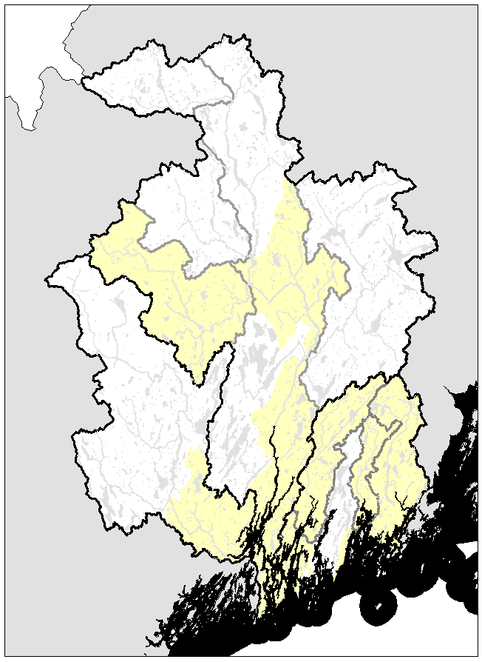
Critical Habitat
Damariscotta
Lower Kennebec below Lockwood, including Cobbosseecontee Stream, Togus Stream, and Bond Brook
Kennebec above the Carrabasset including the Carrabasset River

Kennebec between Lockwood Dam and the Carrabasset River

Madomack
St. George
Sheepscot
Sabasticook
Dead
Carrabassett
Sandy
Androscoggin

Sheepscot River

Important Features
- The Sheepscot River and its tributaries have approximately 6,500 units of habitat with an estimated equivalent production capacity of 4,300 units of habitat (estimated as a function of habitat quality and the threats that impair the value of that habitat).
- The Sheepscot River contains the southern-most locally adapted stock of Atlantic salmon in North America.

- Despite having relatively warm water temperatures, the Sheepscot stock appears to perform well while in freshwater compared to other rivers with similar temperatures.

- Sheepscot Lake, Clairy Lake, Long Pond and Branch Pond are important spawning and nursery habitats for alewives.

St. George River and Medomak Rivers

Important Features
- The St. George and Medomak Rivers and their tributaries have approximately 10,000 units of habitat with an estimated equivalent production capacity of 7,000 units of habitat (estimated as a function of habitat quality and the threats that impair the value of that habitat).

- The St. George and Medomak Rivers historically and currently support a robust and productive river herring fishery.

- The St. George has habitat similar in quantity and quality to the Sheepscot River.

- Accept for lake-outlet dams, the habitat in the St. George River is fully accessible as spawning and nursery habitat for Atlantic salmon.

Androscoggin River and its tributaries

Important Features
- The Androscoggin River and its tributaries have approximately 97,000 units of historical nursery habitat for Atlantic salmon. At present, approximately 16,000 units are accessible to salmon, although nearly all of this habitat is above two or more hydro dams of which survival has not been demonstrated to be sufficient to allow for recovery.

- Rumford Falls is believed to be the upper extent of anadromy in the Androscoggin River with the exception of possibly lampreys and American eel.

- Currently, the entire Androscoggin River above Lewiston Falls is obstructed by dams and inaccessible to diadromous fish.

- Other than a small fish friends program, the Androscoggin River does not have an active stock management program for Atlantic salmon. Despite this, Atlantic salmon adults frequently enter the trap at the Brunswick fishway – often assumed to be strays from the Penobscot.

- Given the current configuration of dams and fishways in the Androscoggin, the Little River provides the best opportunities for Atlantic salmon spawning and rearing.

- The lakes in the Sabbatus River are actively managed by Maine DMR for river herring, and currently, provide the best opportunities for river herring spawning and rearing in the Androscoggin drainage.

Lower Kennebec River below Lockwood, including Cobbosseecontee Stream, Togus Stream, Bond Brook

Important Features
- The habitat in the lower Kennebec River is largely unsuitable for Atlantic salmon spawning and rearing because of really low habitat quality and threats. The primary threat is predation by both native and non-native species.
- Togus and Bond Brook provide some of the best opportunities for Atlantic salmon spawning and rearing for fish that choose not to use the fishways at Lockwood or at Benton Falls on the Sebasticook.
- The mainstem Kennebec River is an important migratory corridor for all diadromous fish in the Kennbec River, including Atlantic salmon.

Sebasticook River

Important Features
- The Sebasticook River and its tributaries have approximately 23,000 units of low quality Atlantic salmon habitat with an estimated equivalent production capacity of 5,500 units of habitat (estimated as a function of habitat quality and the threats that impair the value of that habitat).
- The lakes and ponds of the Sabasticook River are currently the most productive river herring waters in Maine, with a lot of additional capacity that is still obstructed by dams.

Kennebec River between Lockwood Dam and the Sandy River

Important Features
- The mainstem Kennebec River and its smaller tributaries between Lockwood and Abenaki has approximately 40,000 units of habitat with an estimated equivalent production capacity of 14,000 units of habitat (estimated as a function of habitat quality and the threats that impair the value of that habitat).
- Lockwood, Hydro Kennebec, Shawmut and Weston Dams are hydro projects within this reach of river, of which Lockwood is currently the only dam with fish passage.

Sandy River and its Tributaries

Important Features
- The Sandy River and its tributaries have approximately 43,000 units of habitat with an estimated equivalent production capacity of 15,000 units of habitat (estimated as a function of habitat quality and the threats that impair the value of that habitat), including the 4 mainstem dams below the Sandy River confluence.
- Four mainstem dams block passage of diadromous fish into the Sandy River. Currently, adult salmon are captured at the Lockwood Dam fish lift and transported into the Sandy River, and an egg stocking program is in place aimed at rebuilding the Sandy River stock of Atlantic salmon.
- The Sandy River has very abundant, high quality Atlantic salmon habitats.
- Juvenile Atlantic salmon originating from an egg planting program in the Sandy perform very well compared to other Maine salmon rivers.
- The habitat in the Sandy is relatively unique within the GOM DPS because of its long, medium to high gradient riffles and alluvial flood plains. Many of the salmon rivers and streams in the GOM DPS are bedrock controlled, non-alluvial systems with long stretches of deadwater between shorter stretches of riffles.
- The high elevation, medium to high gradient riffles keep the Sandy River relatively cool in the summer compared to many of Maine’s salmon rivers, and therefore may be more resilient to the effects of climate change.

Kennebec River above the Sandy including the Carrabasset River

Important Features
- The Kennebec River above the Sandy, and the Carrabasset River and its tributaries have approximately 27,000 units of habitat with an estimated equivalent production capacity of 11,000 units of habitat (estimated as a function of habitat quality and the threats that impair the value of that habitat).
- The Carrabasset River has very abundant, high quality Atlantic salmon habitats.
- Currently, the Carrabasset River is not occupied because of six dams on the mainstem Kennebec that prevent passage of anadromous fish. No Atlantic salmon are currently stocked in the Carrabasset River.
- The habitat in the Carrabasset, much like the Sandy River, is relatively unique within the GOM DPS because of its long, medium to high gradient riffles and alluvial flood plains. Many of the salmon rivers and streams in the GOM DPS are bedrock controlled, non-alluvial systems with long stretches of deadwater.
- The high elevation, medium to high gradient riffles keep the Carrabasset River relatively cool in the summer compared to many of Maine’s salmon rivers and therefore may be more resilient to the effects of climate change.

Habitat suitability is a function of habitat quantity and the qualitative factors that would limit the productive capacity of this habitat such as predation and competition by invasive species, pollution, high water temperatures, etc… “Habitat quality” and Habitat suitability are often used interchangeably in this document, and is only based on the observation of habitat features, and not necessarily on its measured productive capacity.
The minimum amount of habitat necessary for delisting salmon is 30,000 units in each of the three SHRU’s. These 30,000 units must be in river reaches identified as being suitable for spawning and rearing based on the habitats productivity, and accessible such that fish passage at any dams among the 30,000 units allows for both survival and recovery of Atlantic salmon. Though the minimum amount of habitat required for delisting salmon is 30,000 units in each SHRU, the actual amount necessary to fully achieve all recovery criteria may be higher depending on the productivity of the habitat, and the degree in which the threats to survival are addressed, particularly the threats associated with dams.

